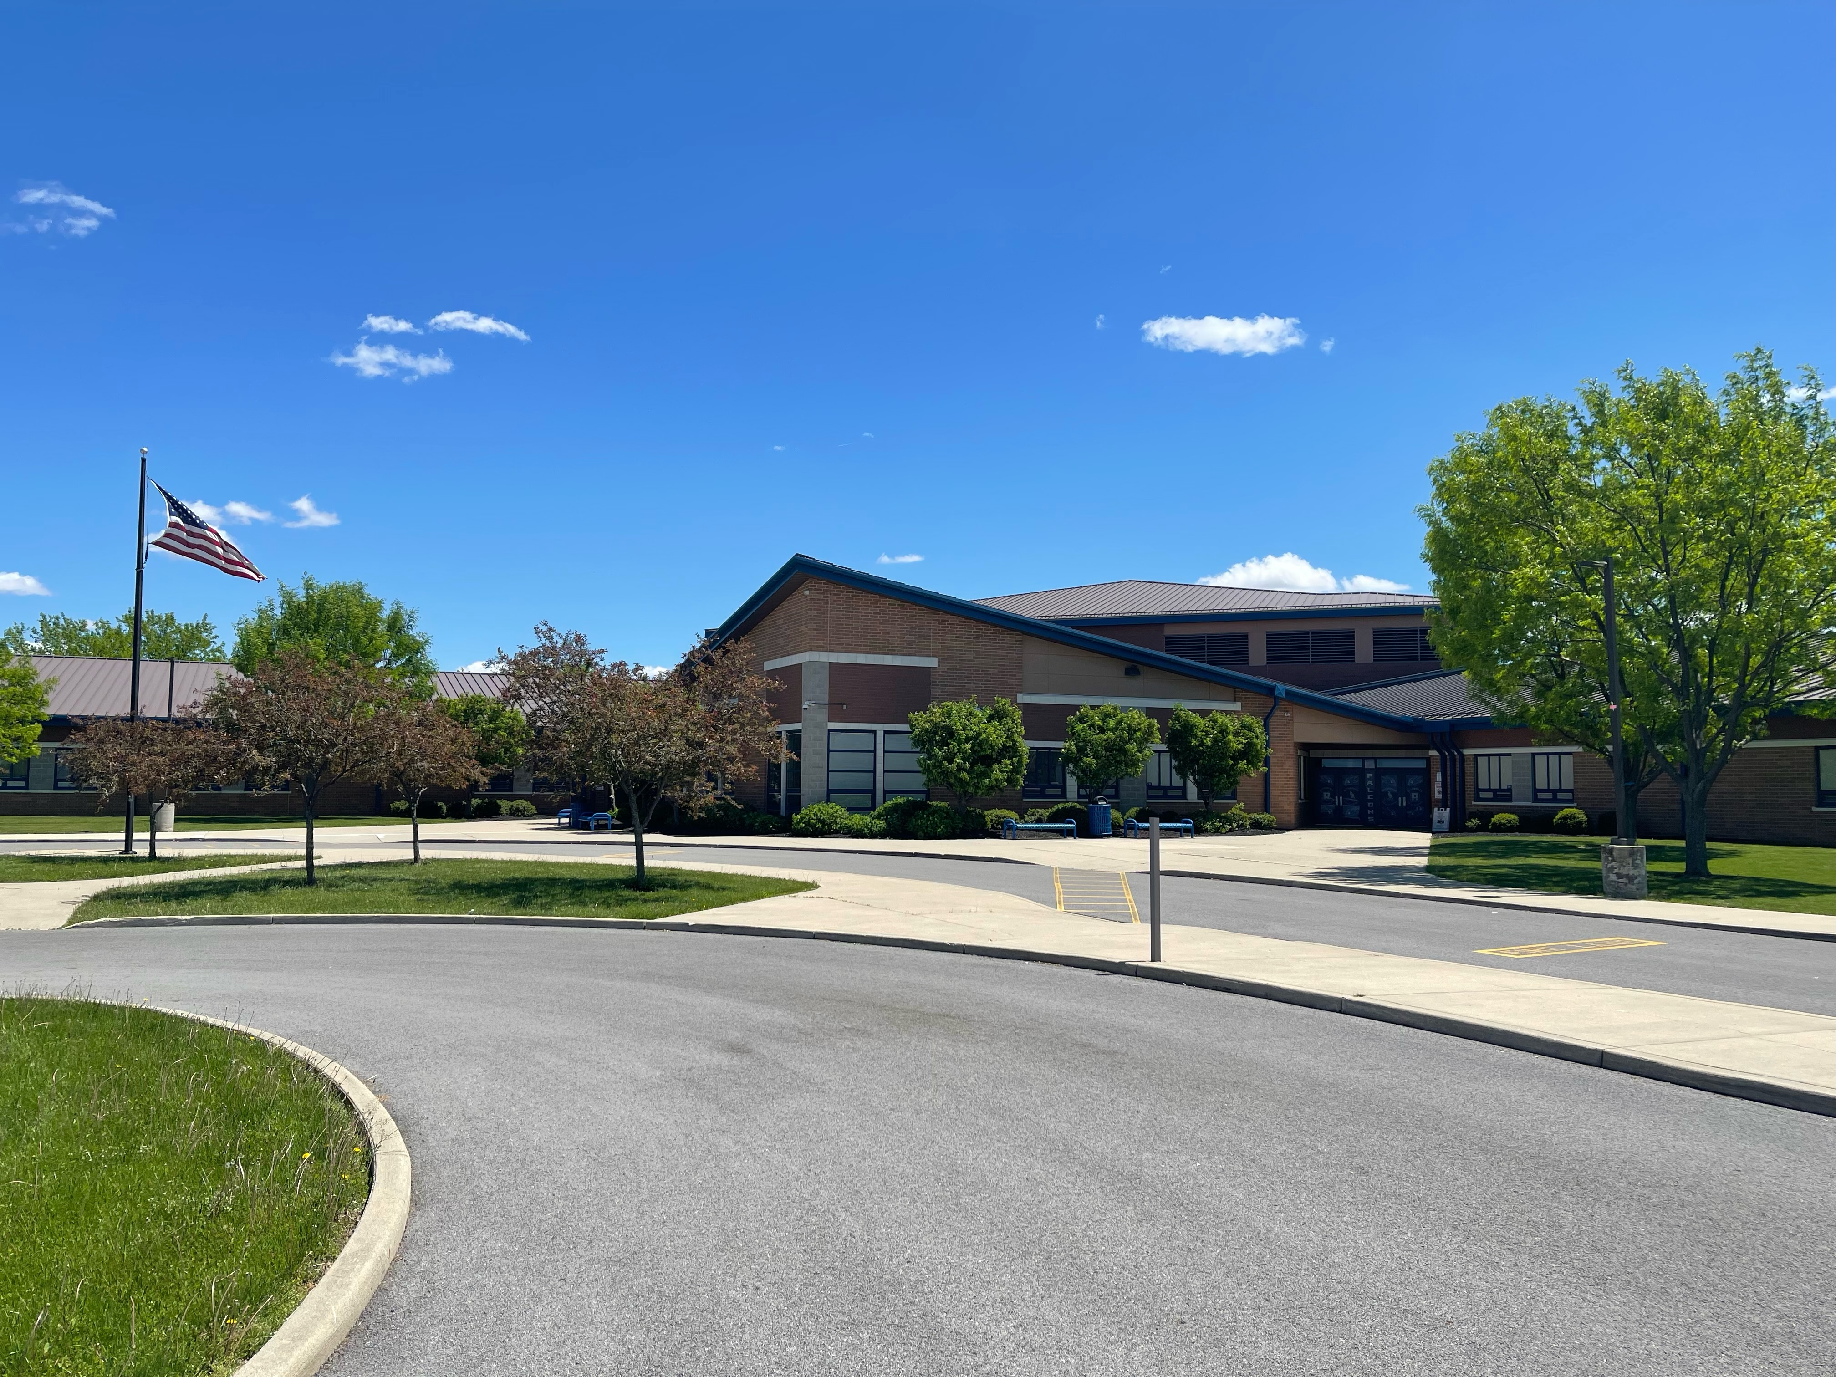
SUPERINTENDENT SEARCH
Riverdale Local Schools
20613 SR 37
Mt. Blanchard, Ohio 45867
419-694-2211
riverdale.k12.oh.us
(Hancock County)

Riverdale School District Strengths:
- Superior commitment to academic improvement, with an excellent, progressive teaching staff.
- Very well-maintained school facilities that complement the educational program, with a new K-12 building completed in 2004.
- Recent renovations to the central office/exceptional children classroom building.
- Community support and strong pride in the school system.
- Very favorable teacher-student ratio.

Needs Facing the Riverdale School District:
- Continue to remain focused on maintaining strong fiscal responsibility.
- Need to pass a tax levy in November 2022.
- Long range plan for facility maintenance.

Expectations for the New Superintendent:
- Be of high ethical and moral character.
- Maintain high professional expectations of school staff within an environment of collaboration.
- Exhibit strong public relation skills, especially in the area of communications.
- Hold students to a high standard of accountability to represent Riverdale schools in the community in a positive manner.
- Maintain a positive rapport with the staff and community.
- Possess a clear understanding of the business functions of the school district and a willingness to work collaboratively with the treasurer.
- Residency is encouraged, but not required.

Salary/Length of Contract:
- Salary and other fringe benefits are negotiable based on the qualifications and experience of the candidate, with the intent of being competitive with area school systems.
- Successful candidate will receive multi-year contract.

Timeline:
- Advertise the vacancy and begin to accept applications = 05/20/2022
- Closing of the application process = 06/01/2022
- Screening of the candidates = 06/08/2022
- Initial interviews = 06/10/2022
- Second interviews = 06/11/2022
- Selection of superintendent by 06/17/2022. Hire at the 06/21/2022 Board of Education meeting
- Start date = 08/01/2022. It is expected that the new superintendent will be in the district a number of days in July to work with the current superintendent.

Required Application Materials:
- An introductory letter expressing reasons for interest in this position.
- An up-to-date resume.
- A copy of a current Ohio license for this position.
- A completed administrative application form available at www.hancockesc.org.
- Three current reference letters.

Contact: Richard Van Mooy, Acting Superintendent, Hancock County ESC, 7746 CR 140, Findlay, Ohio, 45840; 419-422-7525, ext. 226; email - vanmooyr@hancockesc.org

